Duran Moodley

Assignment 1

Portfolio of Evidence Documentation

Contents

Problem Statement 2

Purpose 2

Functionality 2

Programming structures used 2

Additional Functionality 3

Diagrams 4

Flowchart 4

Class Diagrams 12

How the Program Runs 13

Error Handling and Validation 18

Array Structure 20

Lecturer Feedback 21

Corrections 21

Enhancements 21

References 22

# Problem Statement

## Purpose

This Program has been designed to support the needs of a Dvd shop owner at Dvd Blockbusters who needs an application that can assist with keeping track of all dvds that are being hired. Currently, the show owner manually records each dvd hired and finding out whether the dvd is available or not is difficult. Additionally, the dvds don’t have unique barcodes therefore making the process of finding the dvd even more challenging. Lastly, the shop owner feels that his employees are not charging the customers the proper sales price causing the business to suffer financial losses. The shop owner therefore needs an application to solve the above problems and problematic tasks simpler.

## Functionality

This Program can do the following functions:

* Search for a Dvd
* Display All Records of each Dvd Hired and Customer information
* Saves the records to a Text file
* Converts text to Speech Output
* Generates a unique 9 digit Random Number and 2 Random Characters for the Dvd barcode
* Generates a unique 3 Digit Random Number and first Characters of the customers first name and last name for the customer ID

## Programming structures used

These are the following programming tools that I have implemented in this assignment:

* Array List
* 2 two Dimensional Arrays
* Nested if statements
* Nested for statements
* Try Parse
* Reference parameters
* Formatted Currency
* Random Generator
* Change Colour of Text
* Display Current Date and Time
* Changed Console Property
* Implemented Dialog Boxes
* Classes

## Additional Functionality

* The program also incorporates speech output into the program to provide additional user feedback and to assist users who have limited eye sight.
* I have also made user of colour schemes. This adds more interest to the program and notifies the user of errors and data to be entered in. (All instructions are yellow and error messages are red)

# Diagrams

## Flowchart















## Class Diagrams



# How the Program Runs

First the user will be greeted with some voice output, thereafter a dialog box will appear.

The user will then be prompted to enter in all the full names of the dvds that have been hired. As each dvd is being entered it shall be filled into an Array List. “XXX” will stop the entering of the dvds. Once the user has stopped entering the dvds hired, the computer will generate a unique 9 digit random number and 2 random characters for the dvd barcode.

Once the user has entered xxx, those values will be filled from the Array list to a 2 dimensional array called arrHiredDvds. The user will then be prompted to enter in the Genre of each dvd hired and how much it cost. Furthermore, the program will then prompt the user to enter in details of who is hiring that dvd. Those details will include: Name, Contact Number and address. During this process, the computer will generate a customer ID consisting of a unique 3 Digit random number and the first character of the customers first name and last name.

Completion of this process will take the user to the main menu. The user can select any option they prefer.

**Option A** allows the user to check if a dvd has been Hired or not. If it has been hired, this means the dvd is unavailable. If the dvd is unavailable, the application will output who is currently hiring the dvd. If the dvd has not been hired it means that its available for hiring. Once a dvd has been searched for, the user will be prompted to search again or stop the search and go back to the main menu.

**Option B** displays a dvd List which will output all the dvds that have been hired and which customer has hired them. The user can also view the total number of sales that should have been made for that day.

**Option C**- Save Records option, sends all the records to a text file so that it can be saved for later use. At the bottom of the textfile, the date of when the dvds were hired are saved. This gives the shop owner an idea of which dvds were hired when.

**Option E:** Allows the user to exit.

Welcomes the user to the program. Speech output has also been used.

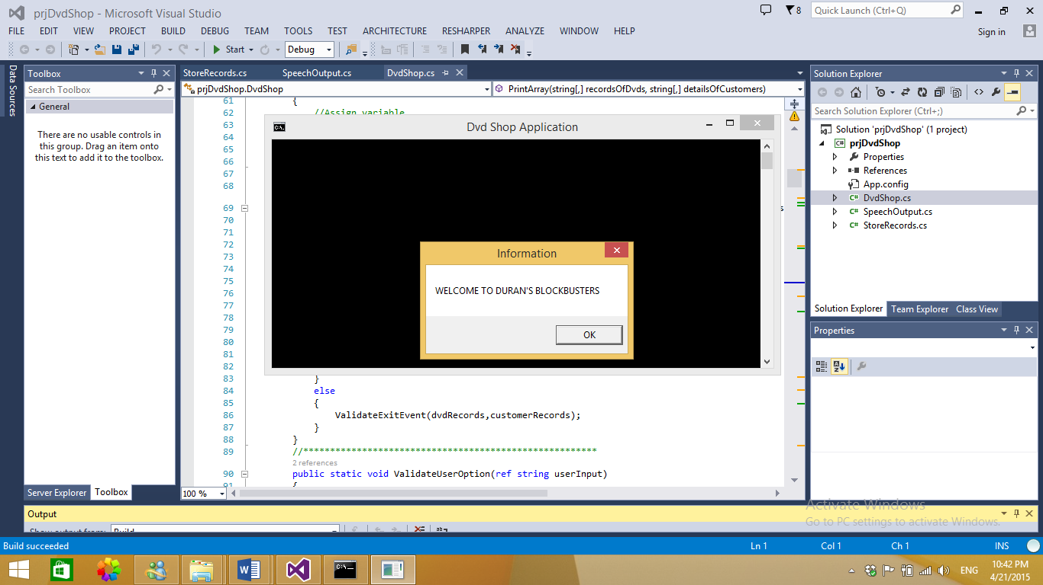

Entering all the dvds that have been hired.

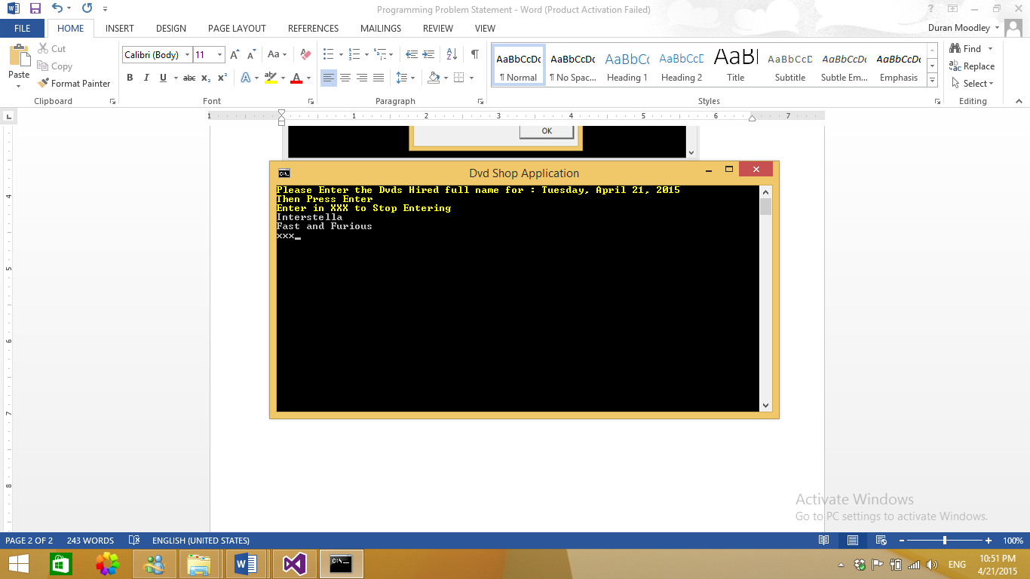

Once the above is complete. Information about who hired the dvds needs to be entered.

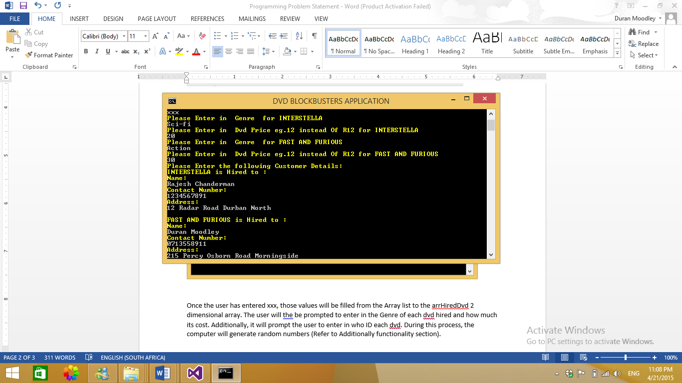

The Menu which contains a list of options.

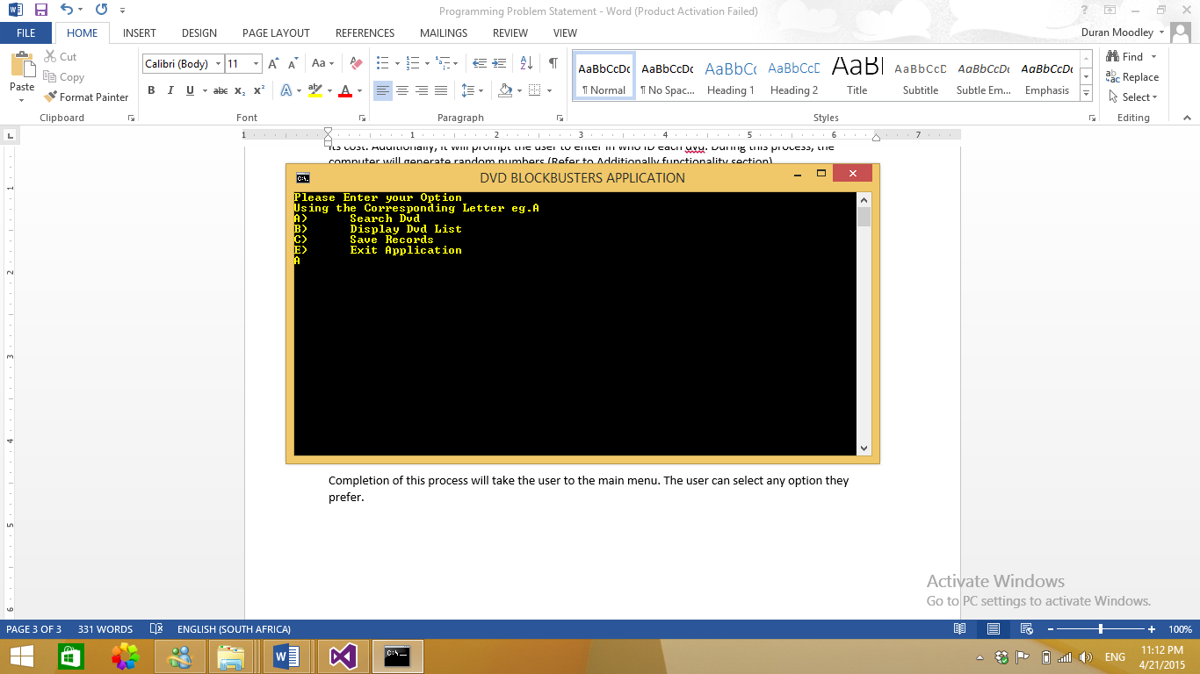

Option A: Searching for a dvd. Requires the unique barcode to be entered.

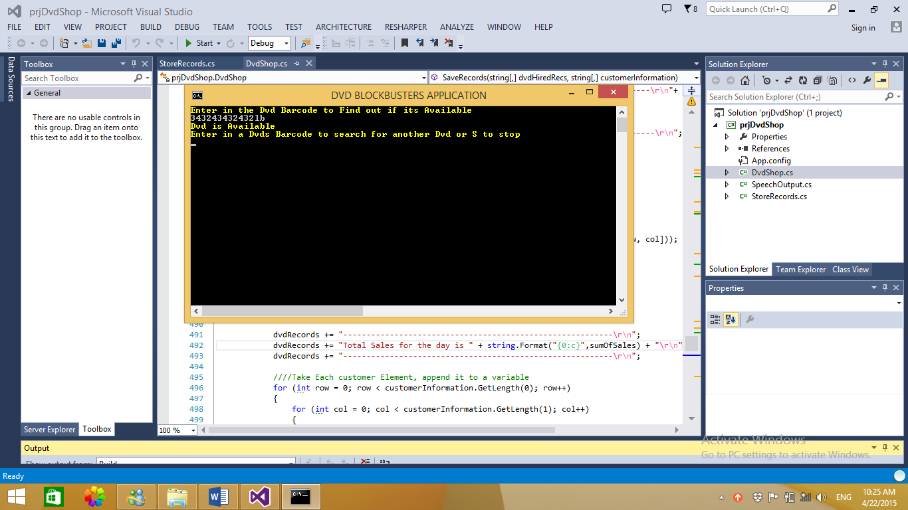

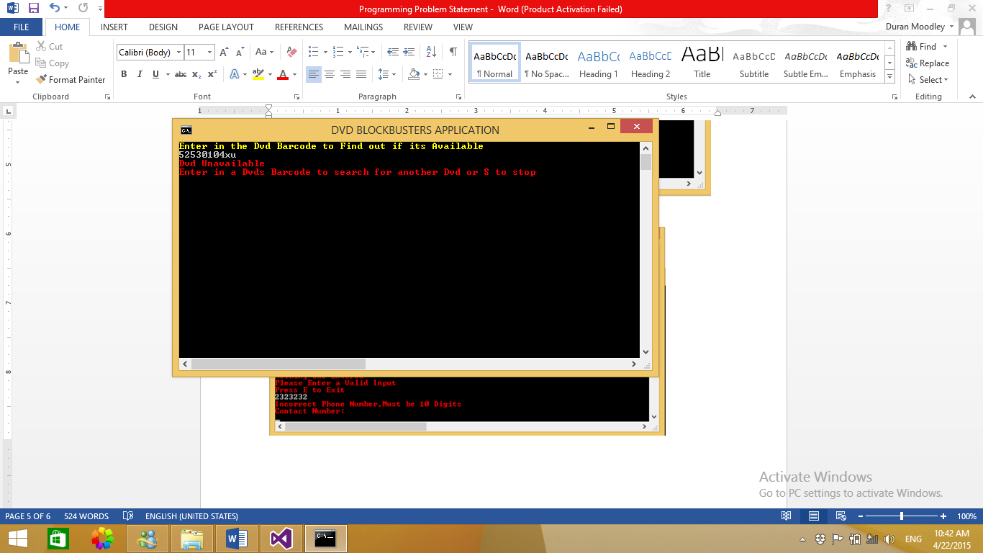

Option B : Displays all records.

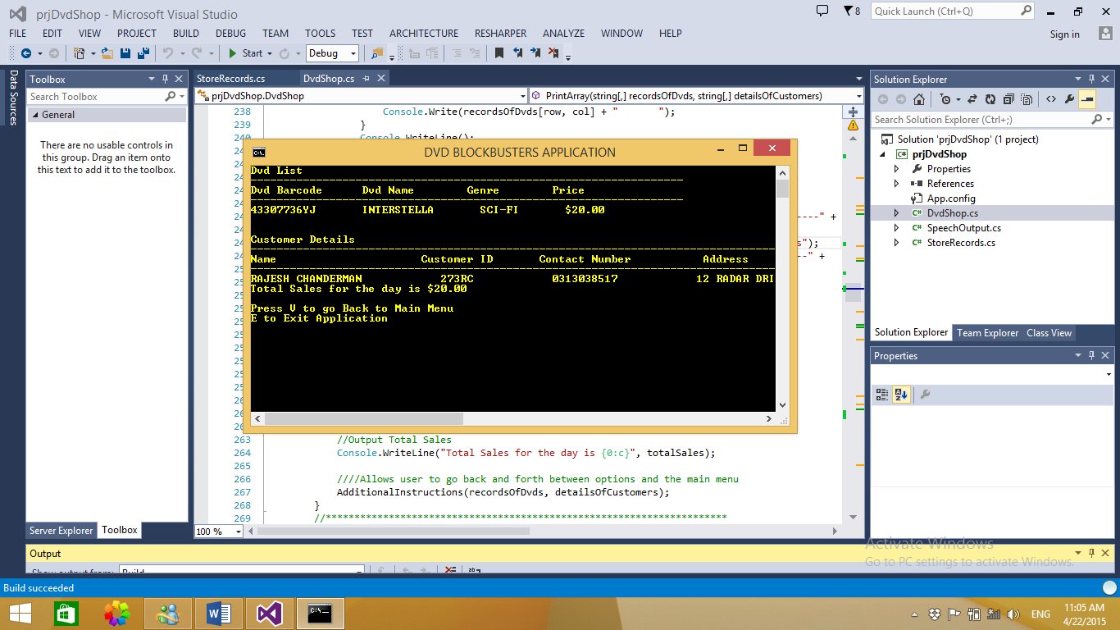

Option C: Saves to a text file

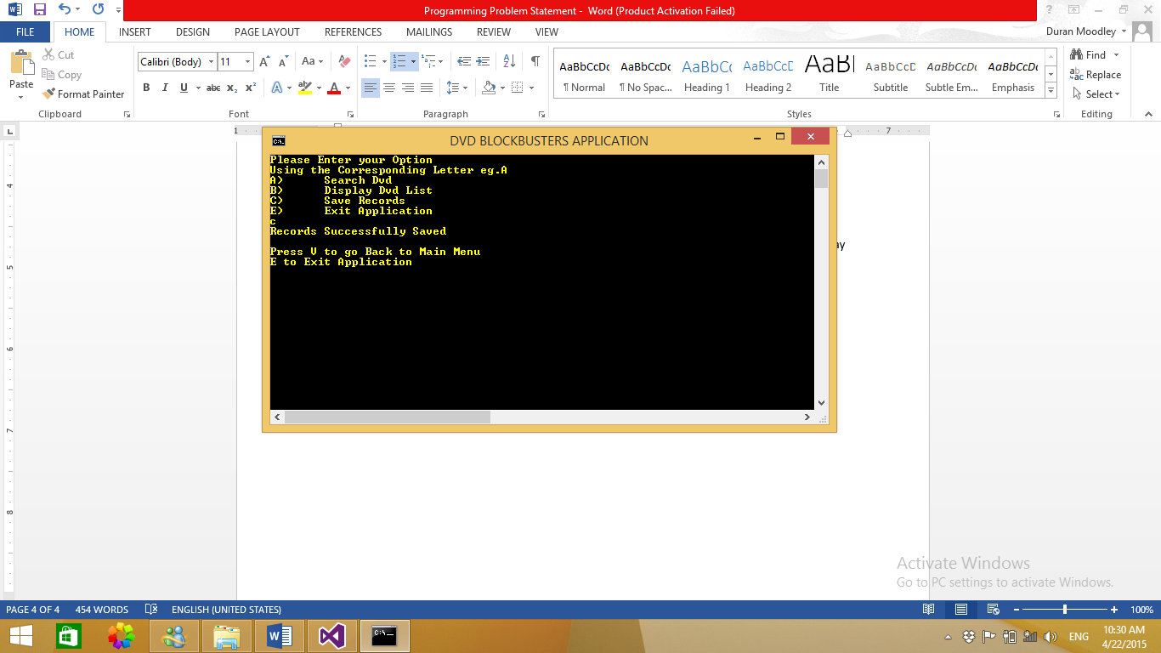

Sample of Text File

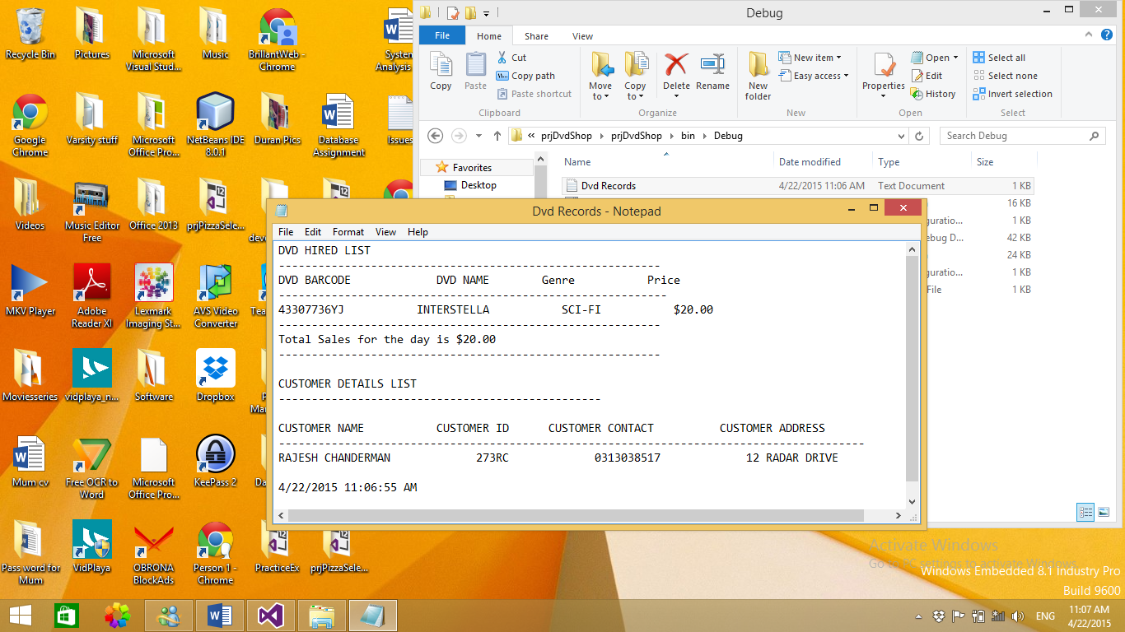

Option E: Allows the user to Exit. A message will appear to confirm if the user wants to exit.

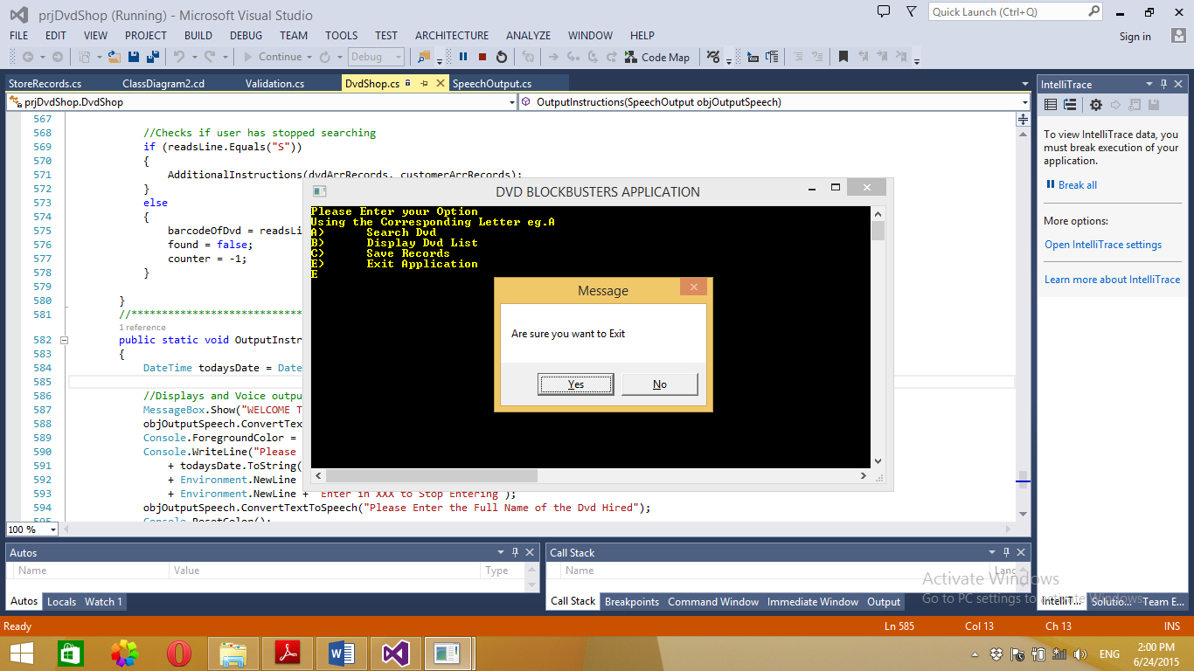

## Error Handling and Validation

An added feature to my program is validation of user input. There are a number of things that are validated. They are: (All Error Messages are in Red)

* Checks if a user as entered a null value (user must enter in some valid input)
* Validates contact number (must be 10 digits)
* Cost of the dvd must be a double.
* Try catch has been used for file handling

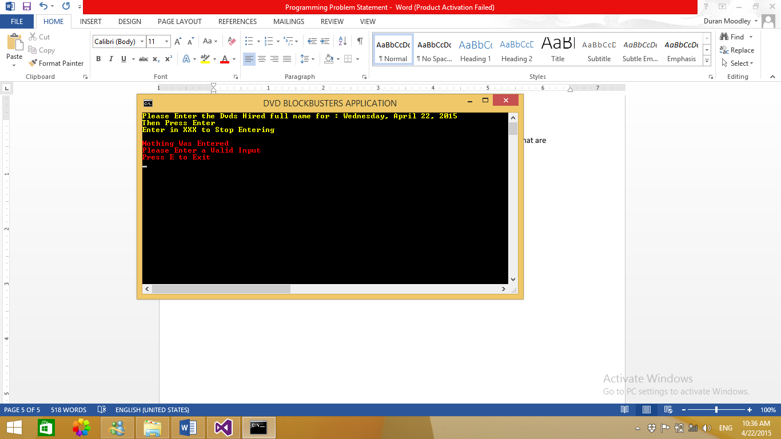

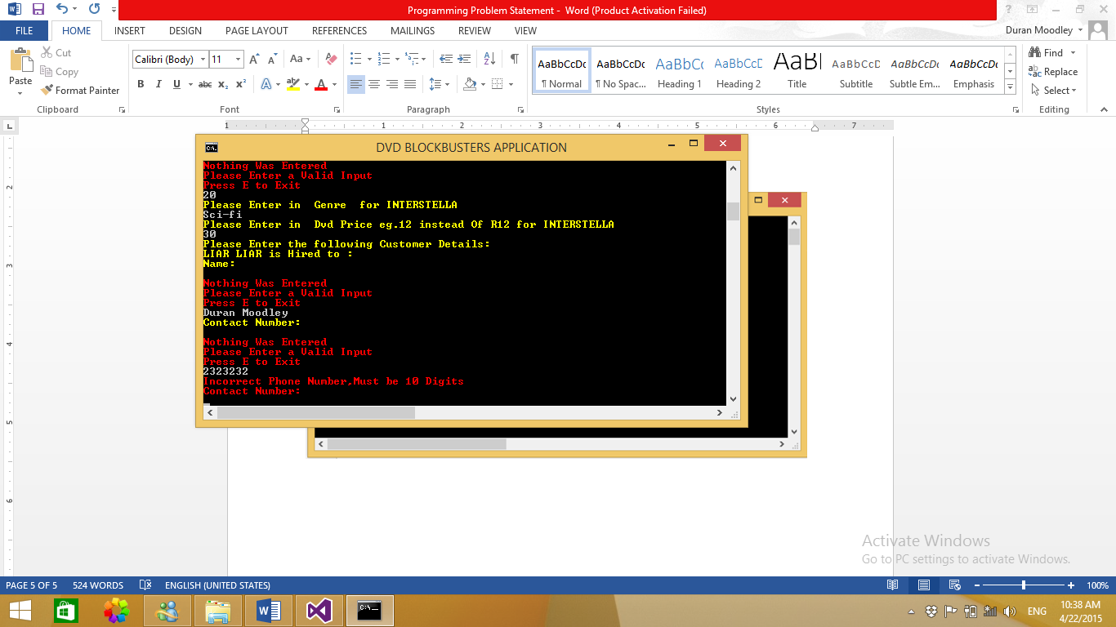

## Array Structure

There will be a method called LoadHiredDvdArray which will fill the arrHiredDvds with user Input.

Eg. Barcode Name of DVD

|  |  |
| --- | --- |
| 23459756LR | Liar Liar |
| 90393929GN | Golden compass |
| 32983923ES | Expendables |

A method Called LoadCustomerDetails will fill this Array called arrCustomerDetails.

Eg.

|  |  |  |  |
| --- | --- | --- | --- |
| 232DM | Duran Moodley | 0313038517 | Unit 2 Flamboyant 215 Percy Osborn Road Morningside  Durban |
| 481MT | Maggaret Thomas | 0313929392 | Unit 8 Courtyard  18 River Road  South Beach  Durban |
| 982MR | Mishka Ramburan | 0319392930 | 2 GIlrock  Gilespie Street  Durban |

# Lecturer Feedback

* Include date at the top of each class
* Use Environment.Newline instead of “/n”
* Use string.Empty instead of “”;
* SpeechOutput Line 11 – speechtext – never used – Remove
  + Line 17 – unused method – Remove
* Dispose objSynthesizer after use
* Store Record class – Line 13 – no calls to get and set
  + Line 22 – unused parameters – remove
* Speech comes after you chose to exit

# Corrections

* Included the Date at the top of each class
* Replaced “/n” with Environment.Newline
* Removed unused SpeechOutput constructor – Line 17
* Reduced LoadHiredDvdArray method. Deleted Instructions to user in the method and the speech output. Instead I created a new method called OutputInstructions() and called it in the Main Method.
* Removed unused variable in Speechoutput class – Line 11.
* Removed parameters from Store Record method writeToTextfile.
* Disposed the object synthesizer in the Speech output class.

# Enhancements

* If a dvd is found, the program will now output who the dvd is currently being hired by.
* I have now added a Validation class.
* I have now sealed all my classes.
* When saving to the text file. The application does not overwrite previous entries.

# References

Speech output: <https://msdn.microsoft.com/en-us/library/ms586901(v=vs.110).aspx>

Get the date and time:

https://msdn.microsoft.com/en-us/library/system.datetime.today%28v=vs.110%29.aspx